**HHS simplified heating needs calculation model**

Arie Taal, Baldiri Salcedo, 10th July 2018

**1. Model structure**

The model consist on 6 subsystems, 4 subsystems where there is data input (grey blocks) and two subsystems where there is data output (yellow blocks)

**5**

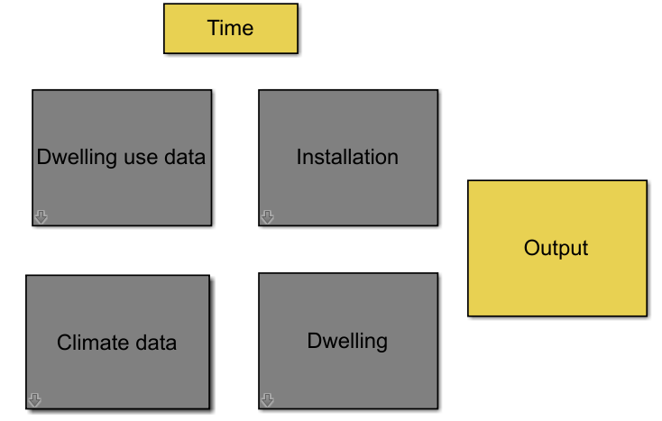

**4**

**2**

**1**

**3**

**6**

**1.1 Dwelling use data**

This blocks contains the input about the thermostat set-points and the internal heat. At this moment both parameters are controlled with the same time schedule. The time schedule is the same for every day.

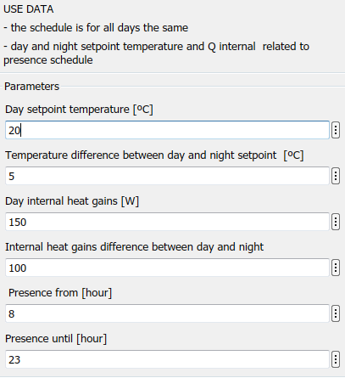

**1.2 Climate data**

The data about the outdoor temperature and the solar radiation is extracted from the current NEN norm. In the block mask it can be chosen between the different NEN norm options.

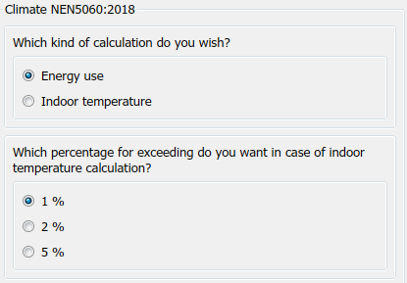

**1.3 Installation**

As the objective of this model was to calculate the energy needs the only information there is about the heating installations is the maximal power that it can deliver and a PID controller.

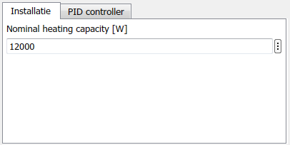

**1.4 Dwelling**

The house block calculates the indoor air temperature and the temperature of the wall. The calculation is based on a model of resistances and capacities. The main dwelling characteristics can be defined in the mask and the building of the matrixes used to make the calculation is made on the script file, init_dwelling.

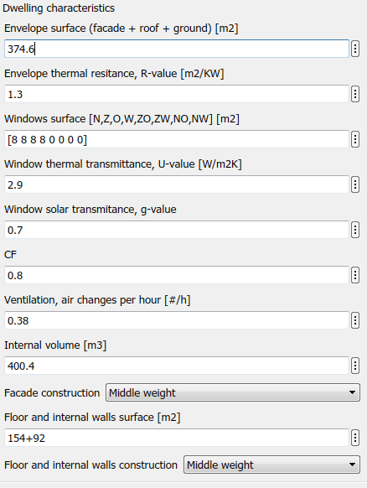

**1.5 Time**

The time block is a really simple block that tells how long has the simulation run. It is useful sometimes when you are testing the model.

**1.6 Output**

Currently there are three graphs as output. A graph of the heating energy needs, a graph of the indoor, wall and outdoor temperature and a graph of the indoor temperature versus the set-point temperature. Each graph block call to a script file.

**2 Model results**

This is in our regard the most simple model of a house that we can make. The model calculates the heating energy demand and make use of the climate data defined by the NEN norm. The model has certainly plenty of limitations, but the idea is to take this model as a basis and built from here on in complexity. We need to take in consideration in any case that more complexity does not always mean more accuracy of the model results.

In order to test the model we have used the data of a detached house building build between 1975 and 1991 from the document document *Voorbeeldwoningen 2011 Bestaande bouw* published by Agentschap NL.

The model calculates a sum of the yearly energy needs of 19776 kWh.

The document *Voorbeeldwoningen 2011* gives a calculated energy use for heating and hot water of 2616 m3 gas. The average gas consumption of hot tap water on a Dutch household is 300 m3gas. Taking into consideration a heating system efficiency of 0,9, the energy need is 20218,68 kWh.

$$\left(2616-300\right)x9,7x0,9=20128,68 kWh$$

This gives us an indication that the model is on the right result range.

**3 Next steps**

The simulated house is a detached house, the objective in the HP launch is to simulate a terraced house. We need to see what are the considerations that needs to be taken into account in order to model a terraced house.

Right now there is only defined one schedule and is the same for every day. The next model should have the possibility to define at least two weekly schedules, one for the thermostat set-point temperature and another for the internal heat gains.

Right now there is a validation on the order of magnitude of the model output. The idea is to test the model with some real data.